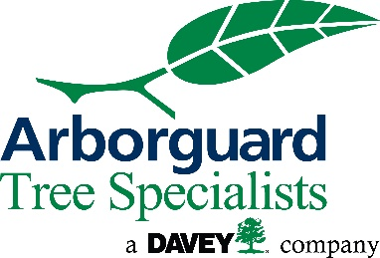
PAVED SURFACE DAMAGE AND LIABILITY RELEASE

This Damage and Liability Release Agreement (the “Agreement”) is made by the undersigned property owner (“Property Owner”) in favor of The Davey Tree Expert Company (“Davey”) pursuant to and as a condition to Davey providing work or services on the Property Owner’s property.
The Property Owner has or will allow Davey to perform work or services (the “Work”) as agreed to by the parties and as further outlined in Davey’s order or quote form dated _____________. In performing the Work, the Property Owner acknowledges and agrees that the Work cannot be reasonably performed without the risk of damage to the paved areas on the property where the Work is to be performed. Further, Property Owner affirms that Property Owner has the right and authority to sign this Agreement.
Pursuant to this Agreement, the Property Owner indemnifies, releases, and agrees to defend and hold Davey harmless from and against any loss or damage to the paved areas on the property where the Work is performed or any liability or damage resulting there from, including, but not limited to, sidewalks, driveways, patios, irrigation systems, underground utilities, or lawn. This Agreement excludes such loss or damage done as a result of Davey’s willful failure or gross negligence related to Davey’s performance of the Work.

Signed and agreed on this _____ day of ____________________, 20______.

______________________________________
Property Owner Signature

______________________________________
Printed Name

